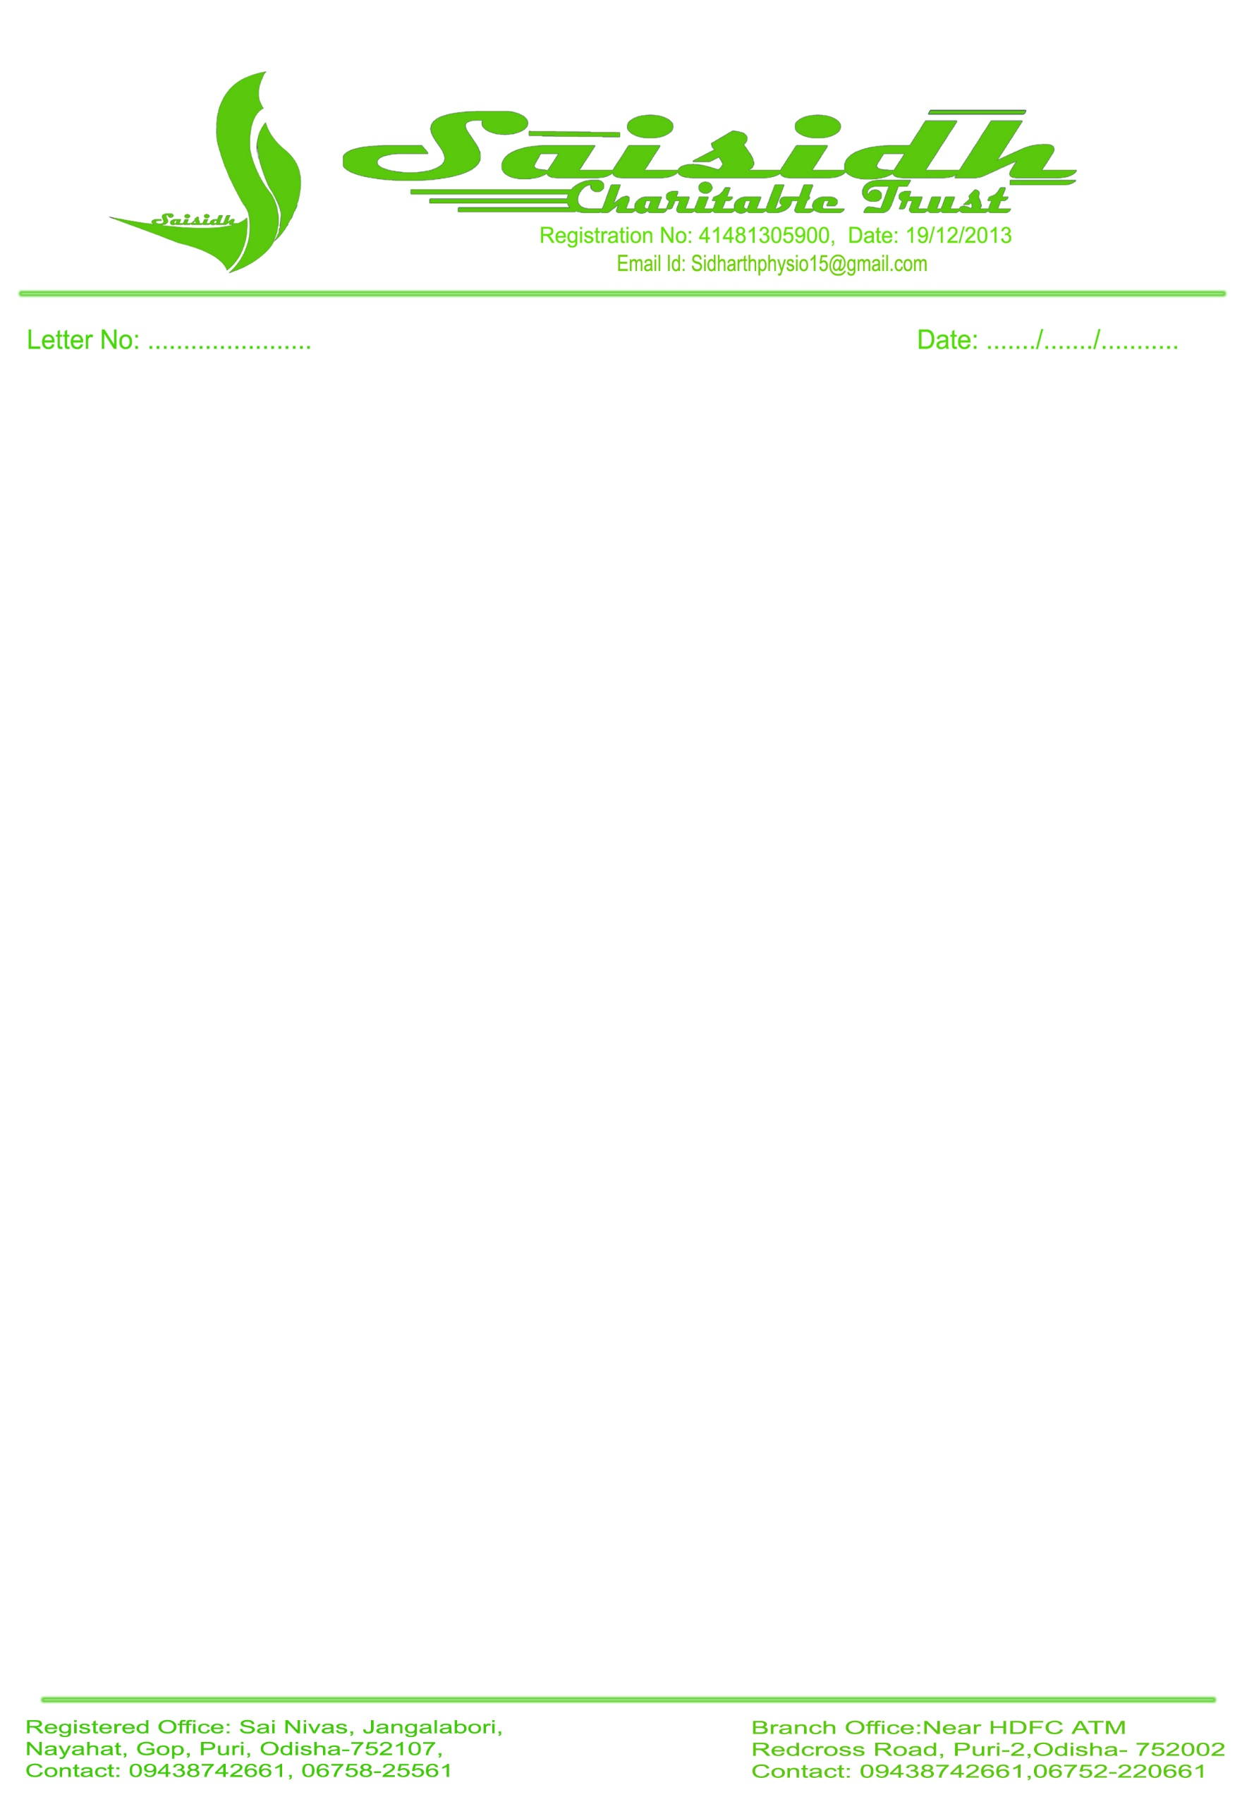**TO**

**THE DISTRICT MAGISTRATE**

**PURI, ODISHA**

sub: permission to provide free services (food & water) at **Grand Road On Ratha Yatra 2024**

Respected Sir,

With ref to the cited subject above I would like to draw you kind attention that we need your kind permission to provide cooked food, dry food, ORS and water on **Grand Road at Badasankha near SBI on Ratha Yatra (7/07/2024) and Bahuda Yatra (15/07/2024).** We need vehicle pass for easy transport to provide the service.

Kindly consider our prayer and do the needful.

Thanking you Yours Faithful

Dr Sidharth Sekhar Patra

Founder cum MD